Lesson and Activity Excerpted from the Tanenbaum Curriculum COEXIST
Hip-Hop Artists

Lesson Overview: Students will learn about stereotypes as well as how to identify and challenge their own biases. Students will also make connections to religion as an important aspect of identity and an influence within the realm of Hip-Hop.

Grades:
6-8, 9-12
Principles for Inclusive Education Explored: Teaching and Learning about Cultures and Religions, Preventing Prejudice, Promoting Social Justice, Exploring Multiple Identities

Skills: Religion, Literacy, Social Studies

Materials: Hip-Hop Lyrics info kit (included), White or Black Board and Markers

MATERIALS PREPARATION:

Prepare handouts of Hip-Hop Artist for students in the class. This lesson is best done in conjunction with Tanenbaum Center’s Hip-Hop Lyrics Lesson, specifically as the first lesson.

PROCEDURE:

Step One: Tell the students that they will begin a lesson which will be brining Hip-Hop into the classroom. You may want to give some background on Hip-Hop as an important social and musical movement which has been embraced by those who feel marginalized.

Step Two: Write Hip-Hop on the center of the white or black board. Begin a discussion with the students by asking what they think about Hip-Hop. Focus on one word answers and facilitate responses by asking what images come to mind, what Hip-Hop artists the students are familiar with, and what topics Hip-Hop discusses. Create a word web with the students’ responses.

Step Three: Handout the Hip-Hop Artists handout with just the pictures of the artists. Ask the students to read the directions, and then read the directions aloud to the students.

Step Four: After all the students have completed the identification of both the artists’ names and religion, have them move into small groups to discuss the following questions:
- Which artists were easy for you to identify?
- Which artists were hard for you to identify?
- How did you determine which religion each artist is affiliated with?

Step Five: Handout the Hip-Hop Artists’ Religion handout. Ask the students, in their groups, to read over the hand out and then discuss the following questions:
- Which artists did you correctly identify? Why were you able to correctly identify them?
- Which artists were you surprised by? Why are you surprised?
- Does knowing any of the artists’ religions help make sense of what you already know of them?
- Can you think of a way in which the artists’ religions influence their songs or lyrics?

Step Six: Bring the class back together as a large group and repeat the discussion, focusing specifically on which artists the students were surprised by and why they were surprised.

Step Seven: Follow up activities can include the following:
- Students can choose an identity salient to them (African-American, Hindu, Nigerian) and find pictures which challenge the stereotypes often held about their group. This could be turned into a classroom gallery.

Hip-Hop Artists

Which religion do your favorite Hip-Hop artists profess? Which artists are Christian? Hindu? Muslim? Jewish? A Jehovah’s Witness? Buddhist? Humanist?
Can you tell by looking at them? Do their lyrics give you a hint?

Mark down the first letter of the religion you think each Hip-Hop artist is (example: C = Christian, H = Hindu) and put a star next to every artist you recognize.

1 ___ 2 ___ 3 ___ 4 ___
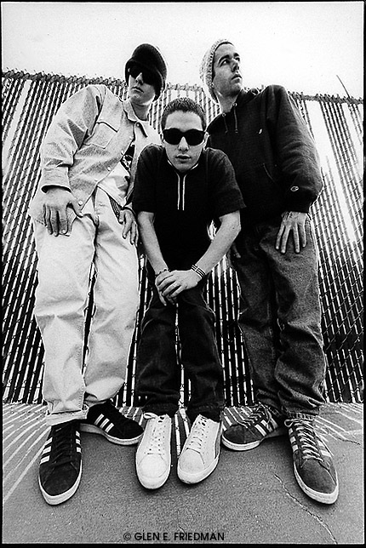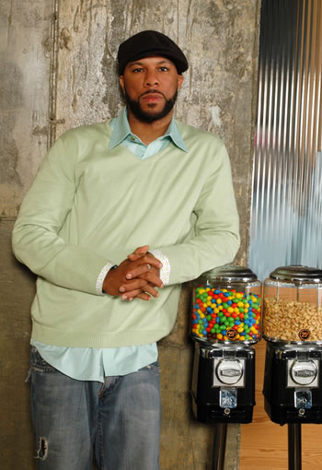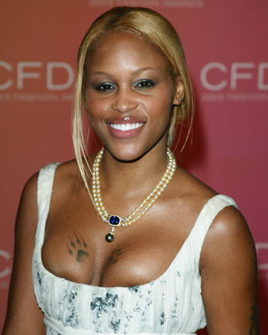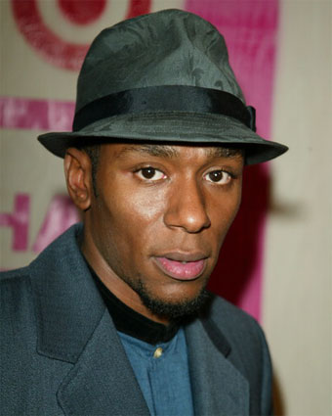

5 ___ 6 ___ 7 ___ 8 ___
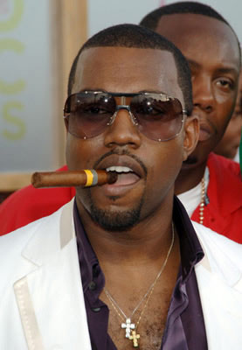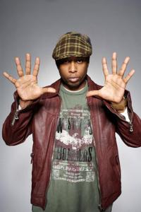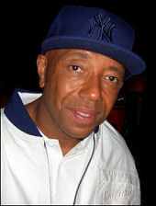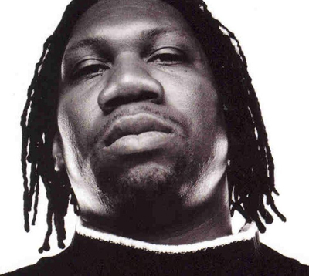

9 ___ 10 ___ 11 ___ 12 __
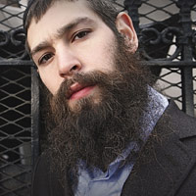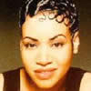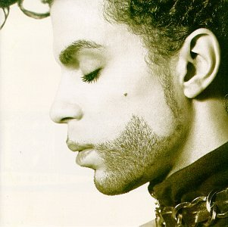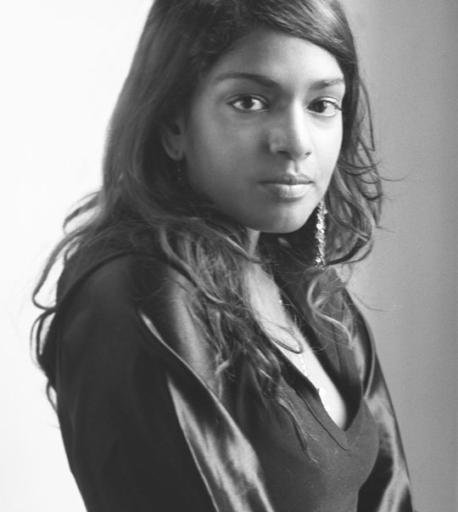

Hip-Hop: Artists’ Religions

1. Beastie Boys – Jewish/ Buddhist
The members of the Beastie Boys Michael Diamond (Mike D), Adam Yauch (MCA), Adam Horovitz (King Ad-Rock) and Michael Schwartz (Mix Master Mike) were all born and raised Jewish. Adam Yauch converted to Buddhism in the mid-1990s. All the members are from New York, and their heritage is mentioned in many of their songs. They are the highest selling Hip-Hop group and the fourth highest selling Hip-Hop artists (behind Tupac Shakur, Eminem, and Jay-Z).
2. Common – Christian
Common (born Lonnie Rashid Lynn, Jr.) is from Chicago and a member of the United Church of Christ, along with fellow members Oprah Winfrey and Barack Obama. He is known for lyrics that reflect his spirituality and commitment to social justice. He was at one point notorious for a feud with Ice Cube before Louis Farrakhan was brought in to mediate their dispute.
3. Eve - Muslim
Eve Jihan Jeffers considers herself a non-practicing Muslim. She is one of the first women of Hip-Hop and has been nominated for numerous awards through the American Music Awards, BET, and other organizations. She has crossed over into other arenas including her own clothing line as well as acting in XXX, the Barbershop series and The Woodsman.
4. Mos Def - Muslim
Mos Def (born Dante Terrell Smith in New York) was first exposed to Islam at age 13 by his father. He became a Muslim at age 19 after getting to know Muslim rappers including Ali Shaheed Muhammad and Q-Tip of the group A Tribe Called Quest. Mos Def has helped to popularize socially conscience Hip-Hop and challenge the promotion of violence in gangster rap. He is also known as an actor and was part of critically acclaimed films such as Bamboozled and Monster’s Ball, and has appeared on Chappelle’s Show and HBO’s Def Poetry.
5. Kanye West – Christian
Kanye West became a born again Christian after surviving a terrible car crash in 2002. He makes his faith known in many of his songs, including “Through the Wire” and “Jesus Walks.” He has used his place within the Hip-Hop community to challenge images and lyrics promoting violence and homophobia. He was very active in the aftermath of Hurricane Katrina and the racial strife that was illuminated by the disaster.
6. Talib Kweli –Humanist
In the past Talib Kweli has identified as Christian and as a 5 Percenter, a branch of Islam. Currently he says he respects religion in general and he tries to put that into his work, but he is not associated with any particular religion. His first name in Arabic means "student" and his last name translates in Swahili to "true". He brings that truth to many of his songs, condemning what he sees as injustice and promoting constructive means of alleviating social strife.

7. Russell Simmons - Buddhist
Simmons is the cofounder of the pioneering Hip-Hop label Def Jam, the founder of the music label Russell Simmons Music Group, and the creator of the Phat Farm clothing line. He is considered the main proponent behind the success of the Hip-Hop movement, having brought Hip-Hop culture into the mainstream. He is also a generous philanthropist who has supported causes ranging from the Hip-Hop Summit Action Network to Hurricane Katrina victims.
8. KRS-One - Christian
As a teenager, Lawrence Parker frequently accompanied the Hare Krishna, earning him the nickname Krisna. KRS-One was originally Parker’s graffiti tag, and after he became popular he created a backronym (phrase that is constructed "after the fact" from a previously existing abbreviation) in accordance with his appreciation of education and being referred to as The Teacha, “Knowledge Reigns Supreme Over Nearly Everyone.” He has been active in anti-violence campaigns and was the initiator of the H.E.A.L. compilation Stop the Violence Movement. As of 2002 he has released a gospel-rap album.
9. Matisyahu – Jewish
Matisyahu ia the Hebrew name of Matthew Paul Miller. He is a member of the Chabad-Lubavitch branch of Hasidic Judaism. As an Orthodox Jew he wears traditional clothing such as a kippah (head covering), has a beard, and does not perform on Shabbat (Friday night through Saturday night). He is known for combining Reggae music and spiritual Jewish lyrics. His album Youth was Billboard magazine's number-one "Digital Album" in 2006.
10. Salt –Christian
Cheryl James is famous as Salt of the female rap group 'Salt-N-Pepa.' Since the group’s breakup in 2001, Cheryl James has gone on to do solo albums and feature in reality television shows.
11. Prince – Christian
Prince Rogers Nelson was raised as a Seventh-Day Adventist and converted to become a Jehovah’s Witness in 2001. He is also a vegetarian, which may be connected to his religious beliefs. His music has spanned myriad styles; from his early material, rooted in R&B, funk, and soul, he has constantly expanded his musical style throughout his career, absorbing many other genres including New Wave, pop, rock, blues, jazz, and Hip-Hop.
12. M.I.A. - Hindu (Batticaloa)
As an ethnic Sri Lankan Tamil, Mathangi “Maya” Arulpragasm practices a form of Hinduism specific to that region. Maya spent her life traveling between England, Sri Lanka and India due to her father’s affiliation with the militant Tamil group, LTTE (Liberation Tigers of Tamil Eelam). Her chosen Hip-Hop moniker reflects her activist roots, M.I.A. can stand for either “Missing in Acton,” referring to an area of London, or “Missing in Action,” the military term for someone who is missing in combat. Her musical style contains elements of grime, Hip-Hop, dancehall, electro, and baile funk. She does a great deal of graffiti artwork as well as socially conscious songs.

